

**KINGSWAY CHRISTIAN COLLEGE**

**Year 12 ATAR Physics 2017**

**Task 8**

**Wave Particle Duality & Quantum Theory Test**

Name ___***An Swerkey***

Date due: ***Friday, 04 August 2017***

**Time allowed 80 minutes**

|  |  |  |
| --- | --- | --- |
|  | **Available mark** | **Student mark** |
| 1 | 12 |  |
| 2 | 8 |  |
| 3 | 11 |  |
| 4 | 12 |  |
| 5 | 10 |  |
| 6 | 22 |  |
| 7 | 6 |  |
| ***Total marks*** | ***80*** |  |
| ***%*** | ***100*** |  |

1. Scientists use models which could be rejected and then later accepted as evidence supporting the model becomes overwhelming.

(a) What is a scientific model? [2]

***A representation of some phenomenon, generally in terms of things already known and familiar to us.***

(b) List three phenomena that support the particle nature of light. [3]

***Photoelectric effect, Black body radiation, Compton scattering,***

(c) List three phenomena that support the wave nature of light. [3]

***Diffraction, Interference, Dispersion***

(d) List two phenomena that support both the wave and particle nature of light. [2]

***Reflection; refraction***

(e) Name two devices developed from the application of quantum Physics that have significantly changed many aspects of society. [2]

***Lasers, photocells, photovoltaic cells.***

2. (a) What is the photoelectric effect? [2]

***The emission of electrons by materials when subjected to electromagnetic radiation of appropriate frequency (energy)***

(b) A photon of blue light has a wavelength of 450 nm. Calculate the:

(i) Photon’s energy in eV. [2]

$$E=\frac{hc}{}=\frac{6.63 10^{-34} 3 10^{8}}{450 10^{-9}}=4.42 10^{-19}J= \frac{4.42 10^{-19}}{1.6 10^{-19}}=2.7625 ≈2.76 eV$$

(ii) Photon’s momentum [2]

$$p= \frac{h}{}=\frac{6.63 10^{-34}}{450 10^{-9}}=1.47 10^{-27} kg.m.s^{-1}$$

(c) Give two uses of the photoelectric effect. [2]

***Photocells (Photoelectric cells) in which electrons produced by the photoelectric effect are used to generate a current. Used in electric ‘eyes’; radiation detectors; light metres.  
Solar Cells (Photovoltaic devices) employ the semiconductor silicon and use the photoelectric effect as well. Used to provide power for space satellites, remote satellites, homes and offices as an alternative environmentally friendly power source.***

3. (a) Explain why the photoelectric effect supports the particle model of light rather than the wave theory? [3]

***Classical wave theory predicts that:***

* ***Electron emission is independent of the frequency of the incident light; and***
* ***As the intensity increases, the energy of the electrons increases.***

***Both these predictions are shown experimentally to be incorrect. By relating energy and frequency in E = hf, the photon theory of Planck and Einstein explains the photoelectric effect.***

***(NB. The wave theory of light, so successful in explaining interference and diffraction of light, is completely inadequate when applied to the photoelectric effect. Only the photon theory can explain the experimental results. To explain all properties of light, both theories must be used. This is the wave-particle duality of light.)***

(b) It is found that when light above a certain frequency illuminates the surface of a metal, electrons are liberated from the metal. In an experiment to determine how the maximum kinetic energy of the emitted electrons varies with frequency, the following graph was obtained.

***f0***

(i) Write an equation for this line. [1]

***Ek = 2f − 2f0***

(ii) Explain the significance of the frequency ***f0***. [2]

***It is the threshold frequency for emission of photoelectrons. Photoelectrons can be emitted for an incident photon with frequency greater than or equal to f0. Emission of photoelectrons is not possible for incident photons with frequency less than f0.***

(iii) What will be the maximum kinetic energy of the electrons emitted at frequency 3***f0***? [2]  
  
***EK = 2 × 3f0 − 2f0 = 4f0  = 8 arbitrary energy units***

(iv) What is the work function of the metal and where would it plot on the graph? [2]

***The work function of the EK when f = 0 = − 2f0 which will plot − 4 arbitrary energy units on the EK axis.***

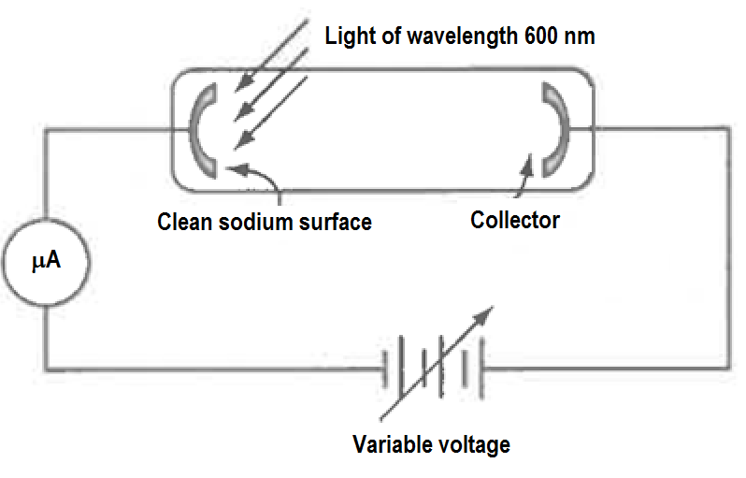4. Light of wavelength 600 nm is shone unto a clean sodium surface. Sodium has a work function of 3.7 × 10−19 J. The diagram of the setup is shown below.

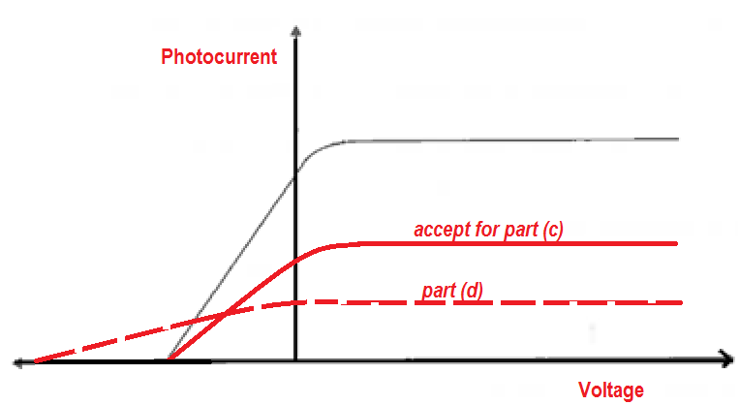The output of the micro ammeter reading as the voltage is increased from very negative values towards positive values is plotted below.

(a) What is meant by work function? [1]

***The minimum energy required to remove the least bound electron from a surface by photoemission.***

(b) Calculate the energy of the light photon in eV. [2] $$E=\frac{hc}{}=\frac{6.63 10^{-34} 3 10^{8}}{600 10^{-9}}=3.315 10^{-19}J= \frac{3.315 10^{-19}}{1.6 10^{-19}}=2.0719 ≈2.07 eV$$

(c) What is the stopping voltage for the photoelectrons produced. ***None as the energy of the photons are less than the work function*** [1]  
(c) On the photocurrent/voltage sketch, draw the graph if the intensity of the 600 nm light was reduced to ½ it’s initial intensity. ***No photocurrent will be produced (see graph)*** [2]

(d) On the photocurrent/voltage sketch, draw the graph if instead of the 600 nm light, a 300 nm UV photon of ¼ it’s initial intensity was used. [2]

(e) The 300 nm UV photons are from a 5 mW source with an efficiency of 80%. How many photons would this source emit in 3 minutes? [4]

5. Define the following terms:

(a) Spectrum [1]

***The range of wavelengths of emr that can be observed or measured is called the spectrum.***

(b) Continuous spectrum and substances that produce it. [2]

***A spectrum that contains all possible wavelengths (energies) of emr (including all the colours of the rainbow) is called a continuous spectrum.  
In general, “Black bodies” produce this type of spectrum.   
Specifically solids, liquids or very dense gases produce continuous spectra. This is because the atoms are so close together that they interact with each other making it possible for all wavelengths to be produced albeit in different proportions for different substances and temperatures.***

(c) Emission spectrum and substances that produce it. [3]

***Atoms of elements excited by heating or passing electric discharge through them emit emr of definite wavelengths called line emission spectra especially when viewed through a spectroscope. Excited gaseous atoms produce these. Excited gaseous molecules produce “band” emission spectra as the emission lines are two close together due to the interaction of the bonded atoms.***

(d) Absorption spectrum and substances that produce it. [3]

***Cool gaseous atoms produce absorption spectra as “white light” (the whole emr spectrum) is passed through them and the emergent light is viewed through a spectroscope. The wavelengths of the incident emr corresponding to the energy level differences in the atoms are absorbed so appear as dark absorption lines on a rainbow coloured bright background. Cool gaseous molecules produced absorption “bands” when white light is passed through them and the emergent light is viewed through a spectroscope.***

(e) Spectroscope [1]

***A device for visually observing spectra. It could be made of a transparent prism or diffraction grating. It helps to separate or disperse the visible spectrum into the respective wavelengths.***

6. The energy level diagram for a hydrogen atom is shown below.

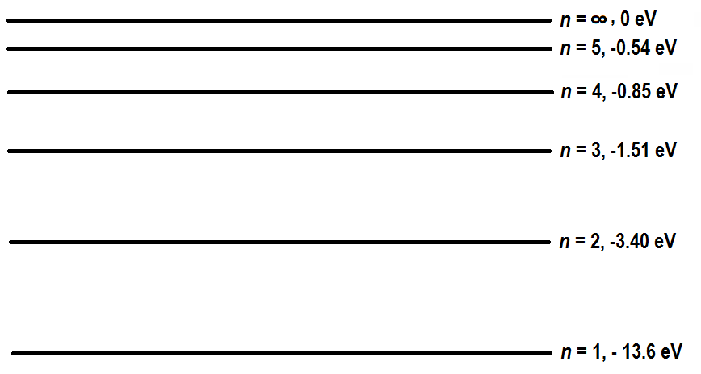

(a) 14.9 eV photons interact with hydrogen atoms in the ground state. Fully describe the result of this interaction. [4]

***Some photons will simply pass through the atoms without interaction.  
Since 14.9 eV is higher than the ionisation energy of 13.6 eV, some photons will give all their energy to the ground state electrons which are then ejected from the atom with a kinetic energy of 14.9 − 13.6 = 1.30 eV***

(b) 14.9 eV electrons interact with hydrogen atoms in the ground state. Fully describe the result of this interaction. [6]

***Some electrons will simply pass through the atoms without interaction. Coming out as scattered electrons with energy 14.9 eV.  
Since the incident electron energy of 14.9 eV is higher than ionisation energy, some electrons will obtain ionisation energy from the incident electrons and will be ejected with kinetic energies ranging from 0 eV to 14.9 − 13.6 = 1.3 eV.***

***The emerging incident electrons now called scattered electrons that led to ionisation, will also come out with energies ranging from 0 eV to 1.3 eV.***

***Other incident electrons will excite the electrons to all the possible higher energy levels***

***Energy level differences:   
n1 → n5 = 13.6 − 0.54 = 13.06 eV  
n1 → n4 = 13.6 − 0.85 = 12.75 eV  
n1 → n3 = 13.6 − 0.54 = 12.09 eV  
n1 → n2 = 13.6 − 3.40 = 10.20 eV   
  
Scattered electron energies would be:***

***n1 → n5 = 14.9 − 13.06 eV = 1.84 eV  
n1 → n4 = 14.9 − 12.75 eV = 2.15 eV  
n1 → n3 = 14.9 − 12.09 eV = 2.81 eV  
n1 → n2 = 14.9 − 10.20 eV = 4.70 eV***

***and 14.9 eV for the ones that didn’t interact.***

(c) Electrons of a certain energy interacted with hydrogen atoms in the ground state. The scattered electron energies after interaction with the hydrogen atoms were   
0.14 eV, 0.45 eV, 1.11 eV, 3.00 eV, and 13.2 eV.

(i) What was the energy of the interacting electrons in Joules. [2]

***The interacting electrons must have energy corresponding to the highest energy of the scattered electrons = 13.2 eV = 13.2 × 1.6 × 10−19 J = 2.112 × 10−18J.***

(ii) List all possible photon energies in eV, emitted by the excited hydrogen atoms. Show the transitions responsible for the photon emissions on a clear energy diagram. [10]

***From part B,***

***Energy level differences:   
n1 → n5 = 13.6 − 0.54 = 13.06 eV  
n1 → n4 = 13.6 − 0.85 = 12.75 eV  
n1 → n3 = 13.6 − 0.54 = 12.09 eV  
n1 → n2 = 13.6 − 3.40 = 10.20 eV***

***13.2 eV electrons can excite the hydrogen atoms to level n = 5***

***∴ Emitted photon energies would be  
n5 → n1 = 13.06 eV  
n5 → n2 = 3.40 − 0.54 = 2.86 eV  
n5 → n3 = 1.51 − 0.54 = 0.97 eV  
n5 → n4 = 0.85 − 0.54 = 0.31 eV  
n4 → n1 = 12.75 eVn  
n4 → n2 = 3.40 − 0.85 = 2.55 eV  
n4 → n3 = 1.51 − 0.85 = 0.66 eV  
n3 → n1 = 12.09 eV  
n3 → n2 = 3.40 − 1.51 = 1.89 eV  
n2 → n1 = 10.20 eV***

7. A 38.4 nm photon is required to ionise an atom in the ground state and give the ejected electron a kinetic energy of 10.0 eV.

(a) What is the ionisation energy of the atom? [2]  
***Photon energy, $E_{ph}=\frac{hc}{}=\frac{6.63 10^{-34} 3 10^{8}}{38.4 10^{-9}}=5.18 10^{-18}J= \frac{5.18 10^{-18}}{1.6 10^{-19}}=32.37 eV$***

***∴ Ionisation energy = Eph  − EK = 32.37 − 10 = 22.37 eV = 22.37 × 1.6 × 10-19 = 3.58 × 10−19 J***

(b) What is the approximate slit width that will diffract an electron with the same energy as the 38.4 nm photon? (Neglect relativistic effects) [2]

***Energy of electron = Eph  = 5.18 × 10−18J  
∴ speed of electron $v=\sqrt{\frac{2E}{m}}= \sqrt{\frac{2 5.18 10^{-18}}{9.11 10^{-31}}}=3.37 10^{6}m.s^{-1} this is from\frac{1}{2}mv^{2}=E$  
The approximate slit width will be the wavelength of the electron $$= \frac{h}{p}=\frac{h}{mv}=\frac{6.63 10^{-34}}{9.11 10^{-31} 3.37 10^{6} }=2.16 10^{-10}m$$***

(c) A Ferrari car with a mass of 1400 kg approaches a freeway underpass that is 10 m across. At what speed must the car be moving, in order for it to have a wavelength such that it might somehow “diffract” after passing through this “single slit”? [2]

***To diffract, λ = width = 10m  
∴ $p=\frac{h}{}=\frac{6.63 10^{-34}}{10}=6.63 10^{-35} so v=\frac{p}{m}= \frac{6.63 10^{-35}}{1400}=4.74 10^{-38}m.s^{-1}$***

**END OF TASK 8**